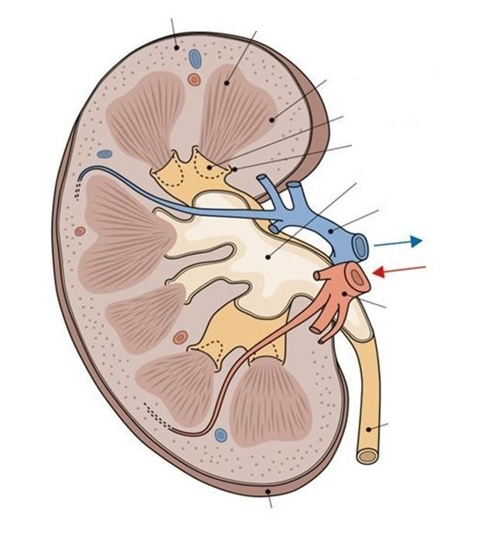

9

8

7

2

4

6

3

5

1

|  |  |
| --- | --- |
| 1 |  |
| 2 |  |
| 3 |  |
| 4 |  |
| 5 |  |
| 6 |  |
| 7 |  |
| 8 |  |
| 9 |  |