Connect 2
Nele Luyckx
Thomas More
Connect 2
Teacher Manual
Inhoud
Curriculum objectives 2
Formation objectives 2
Short-range objectives 3
Lesson lay-out 3
Lesson 1 3
Lesson 2 4
Lesson 3 4
Evaluation options 4
Correction keys 5
Lesson 1 5
Vocabulary part 5
Grammar part: 5
Lesson 2 7
Vocabulary part 7
Language task 8
Extra challenge 8
Lesson 3 10
Source list 11

Curriculum objectives
Le 4 relevante informatie selecteren in (ET 12)

Le 9 Hun functionele taalkennis inzetten en uitbreiden (ET 39). Dit betekent dat de leerlingen hun taalkennis kunnen inzetten om nieuwe boodschappen en teksten te begrijpen; onder begeleiding van de leerkracht nieuwe taalkennis kunnen opdoen als een leestekst als uitgangspunt voor taalstudie gebruikt wordt.
Le 10 Indien nodig, gebruiken de leerlingen de volgende strategieën om hun leesdoel te bereiken (ET 17): - zich blijven concentreren ondanks het feit dat ze niet alles begrijpen; - onduidelijke passages herlezen; - het leesdoel bepalen en hun taalgedrag er op afstemmen; - gebruikmaken van ondersteunende gegevens (talige en niet-talige zoals afbeeldingen) binnen en buiten de tekst; - digitale en niet-digitale hulpbronnen en gegevensbestanden raadplegen; - hypothesen vormen over de inhoud en de bedoeling van de tekst; - de vermoedelijke betekenis van transparante woorden afleiden; - de vermoedelijke betekenis van onbekende woorden afleiden uit de context; - relevante informatie aanduiden.

Sp 8 Hun functionele taalkennis inzetten en uitbreiden. Ze kunnen hierbij reflecteren over taal en taalgebruik (ET 39 & ET 40).
Schr 10 Indien nodig passen de leerlingen volgende strategieën toe (ET 38):
Sp 10 Ze tonen bereidheid en durf om te spreken in het Engels (ET 42*);
Sp 11 Ze streven naar taalverzorging (ET 43*);
Grammar: Situeren in tijd en ruimte Vorming en gebruik van de belangrijkste tijden van de werkwoorden voor de communicatie in de tegenwoordige, de verleden en de toekomende tijd. Productief: future simple en to be going to.
Wo 1: De leerlingen kunnen lexicale elementen (woorden, woordcombinaties en uitdrukkingen) functioneel d.w.z. gepast inzetten om de voor hen relevante receptieve taaltaken (luisteren en lezen) uit te voeren.
Wo 2: lexicale elementen (woorden, woordcombinaties en uitdrukkingen) functioneel d.w.z. gepast inzetten om de voor hen relevante productieve taaltaken (spreken, gesprekken voeren en schrijven) uit te voeren

Formation objectives
Learners can make predictions about the future to express what they want to do some day (language formation), they will feel much more at ease with the fun exercises I want to do with them (personality formation). As a tool in the learning process we will make use of videos and texts (learning strategies).
Learners can make an email to book a room (language formation), they will feel much more at ease working in pairs (personality formation). As a tool in the learning process we will make use of Smart School email (learning strategies).
Learners can make a small travel brochure about a country (language formation), they will feel motivated to learn about a country that they want to visit or they already have visited (personality formation). As a tool in the learning process we will make use of online tools (learning strategies).

Short-range objectives
After reading a text the students have expanded their vocabulary.
After reading a second time the learners can put the new vocabulary together with the explanation (exercise 1.1).
The students can form the future simple.
The students can use the future simple.
After reading the text on page 289, the students can answer questions about the text.
The students can use ‘to be going to’ to express some changes they will make in order to be more eco-friendly.
The students can use the vocabulary to book a room via email.
The students can make a small travel brochure after learning about English speaking countries.

Lesson lay-out
For the students there is a document where everything is listed. There is a clear separation between lesson 1 and 2 of learning the future simple and the vocabulary from unit 8: the road less travelled.
The document is a combination of video links, online tools to learn vocabulary, evaluation, a Power Point and the workbook Connect 2.
The pupil’s document makes use of Tiny Cards to study the vocabulary. They can study each part individual. Below you can find the links to the Tiny Cards, they are also in the pupil’s document.
Vocabulary: it’s a big, big world? | https://tiny.cards/decks/YT466hh4/it-s-a-big-big-world
Vocabulary: the earth… a precious thing but endangered globe | https://tiny.cards/decks/YT4977P3/the-earth-a-precious-but-endangered-globe
Vocabulary: getting around | https://tiny.cards/decks/YT4d62Y9/getting-around
Vocabulary: Yes sir, we do speak English! | https://tiny.cards/decks/YYNEzx72/yes-sir-we-do-speak-english

There isn’t a correction key added to the pupil’s document. So, you can first check if the students did the exercise and then give them a correction key. You can easily check this, by letting the students take a picture of their finished exercises and let them send those pictures to you. Or let them type the answers in a Word document, if possible. Then you want to add feedback to the finished exercise of the pupils, you can do that via an email, document or via Word: select the item you want to give feedback on go to the tab-> ‘controleren’-> ‘nieuwe opmerking’.

Lesson 1
In lesson one the pupils start off with a video about how humans will look like in 1000 years. Then they move on to the future simple. Talking about the future is explained in a Power Point presentation video. (https://youtu.be/SvCZ3LC_A_4 ) After watching the video the students start practising the future simple with exercises in their workbook. They use the pupil’s document as a guideline to know what to do first, second, … Then the lesson ends, the pupils will do the language task at the end of the next lesson. This way they can practise the future simple in lesson 1, if they have any questions, they have time to ask them and they have enough time next lesson to do their language task.

Lesson 2
Lesson 2 starts off with a little quiz from the vocabulary learned in lesson 1. Only the teacher has the link to the online test, so they will have to provide it to the students before they start off with lesson 2. After that they learn some new vocabulary and start working on their language task.
For lesson 2 the same rule applies: take a picture of finished exercises and the teacher provides the correction keys. At the end of lesson 2 you can find some extra assignments that are a bit more challenging for vocabulary and the future tenses. They are optional.

Lesson 3
Lesson 3 starts off with a short quiz, testing the future simple and to be going to.
After the short quiz the pupils have time to work on a new language task: booking a room. In this task they will need to use the vocabulary from lesson 2. They will be provided with a template of an email as an extra handle to write an email.
To finish the third lesson, they will see some new vocabulary and finish off with a smaller language task. The pupils will make a small/short information card about the culture, religion and food. They send their information card to the teacher and he/she can put them together in one map/document. Or they can upload it to a map in Smart School. This way the students made their own little travel brochure, that will become a (class) travel book.

Evaluation options
There is evaluation for vocabulary from lesson 1, from lesson 2 and a quiz: talking about the future. Below you can find the correct links to share with your pupils.
Test talking about the future | https://b.socrative.com/teacher/#import-quiz/46600876
Test vocabulary 1 | https://b.socrative.com/teacher/#import-quiz/46343274
Test vocabulary 2 | https://b.socrative.com/teacher/#import-quiz/46343002

Correction keys

Lesson 1

Vocabulary part
P283- exercise 1.1
P290-exercise 4
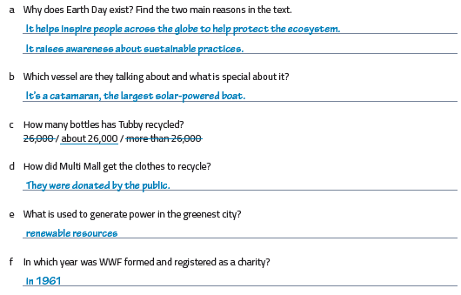

Grammar part:
P286-grammar box
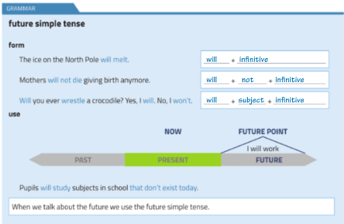

P286-exercise 3.2
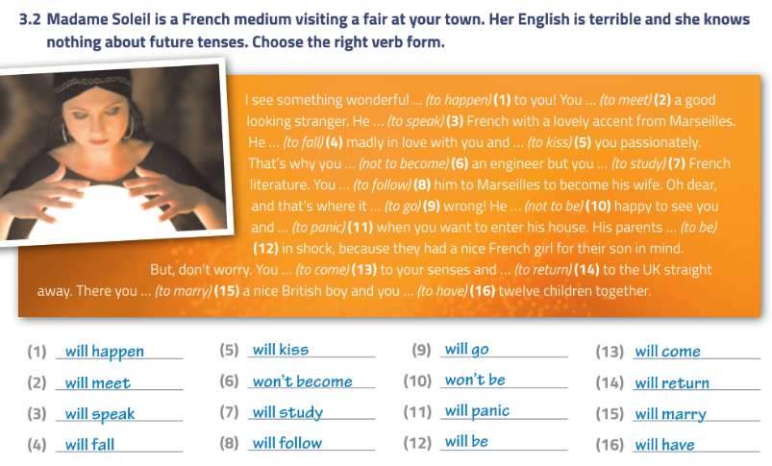
P288-exercise 3.5
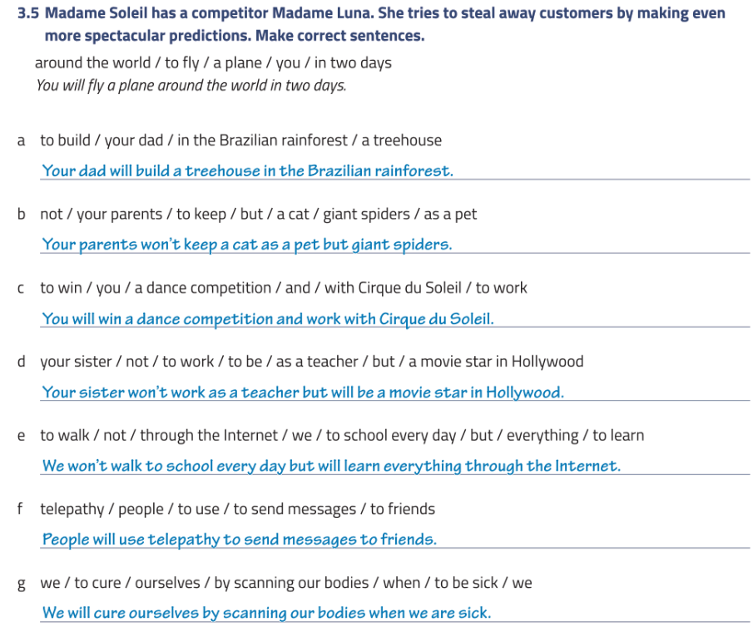

P287-exercise 3.3
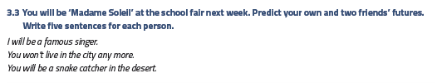
P291-exercise 5a
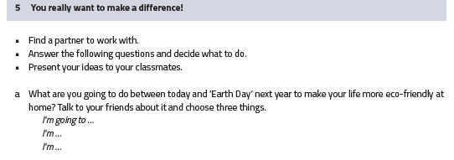

Lesson 2

Vocabulary part
P290- exercise 9.1
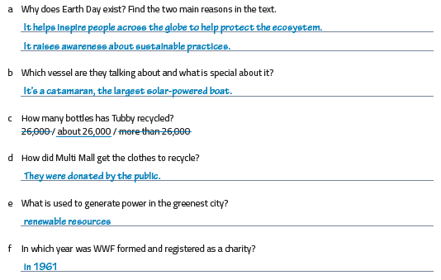

P305- exercise 9.6
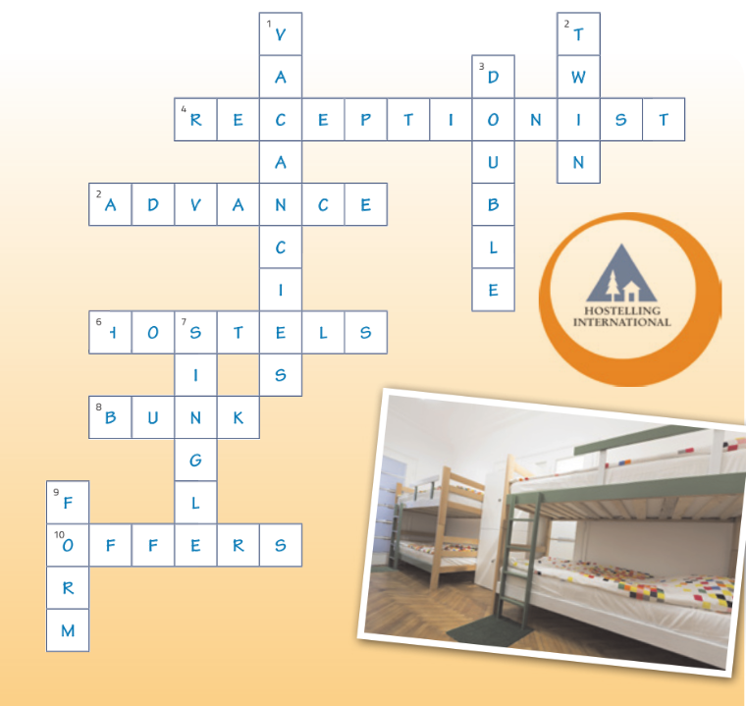

Language task
Correction by the teacher.

Extra challenge

Crossword
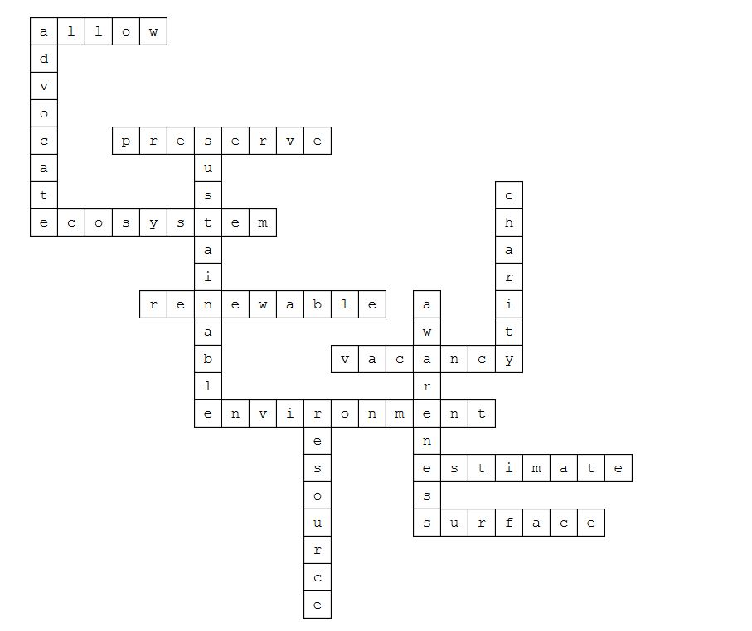

Future tenses
P294- exercise 6.3
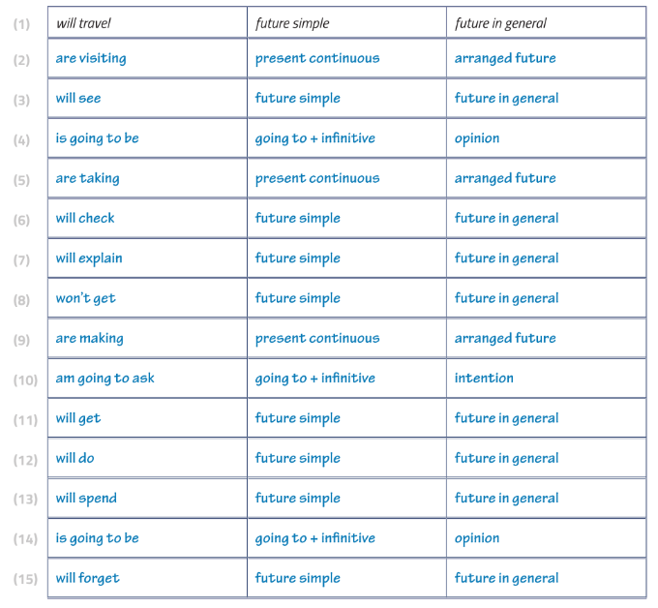

Lesson 3
P311 exercise 12.1
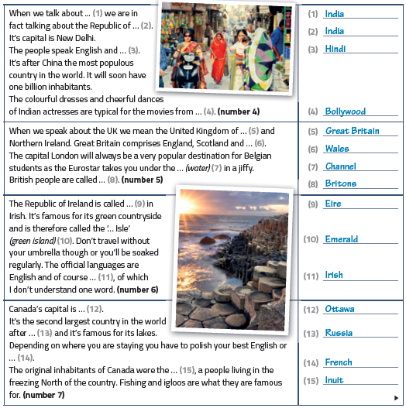
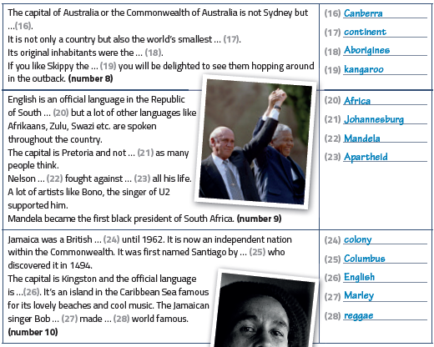

Source list
A.Sanchez. (2012, 07 25). explainity channel. Opgehaald van YouTube: https://www.youtube.com/watch?v=_5r4loXPyx8
Insider, T. (2017, 05 6). What humans will look like in 1000 years. Opgehaald van YouTube: https://www.youtube.com/watch?v=BibBMBibTq0
Quizzes. (sd). Opgehaald van Socrative: https://b.socrative.com/teacher/#quizzes
Seonaid. (sd). simple future. Opgeroepen op 04 14, 2020, van Perfect English Grammar: https://www.perfect-english-grammar.com/simple-future-use.html
The road less travelled. (sd). Opgehaald van Tiny cards: https://tinycards.duolingo.com/profile
The road less travelled. (2016). In M. S. Stefanie Smekens, Connect 2 (pp. 281-321). Mechelen: Plantyn.
VVKSO. Leerplan secundair onderwijs Engels tweede graad aso. D/2012/7841/006.

