22-4-2020
N. Luyckx
Thomas more
Indirect speech
Student bundle

Table of contents
Introduction 2
Indirect speech 2
Time for some practise 2
Language task 2
Attachments 4
Indirect speech overview 4
1) When do we use indirect speech? 4
2) How do we form indirect speech? 4
3) Change of pronouns, demonstratives and adverbs of place and time 6
Bibliography 8

Introduction
Tina says: ‘I like sunflowers.’
Tina says that she likes sunflowers.
‘It is raining.’
He said that it was raining.

Look at the sentences above.
- What does each sentence mean?
………………………………………………………………………………………………………………………………………………………………………………………………………………………………………………………………………………………………
- Which differences do you notice?
……………………………………………………………………………………………………………………………………………………………………………………………………………………………………………………………………………………………….

Watch the following video to introduce the indirect speech (a.k.a. reported speech) https://www.youtube.com/watch?v=cetrtFDN2Zg

Indirect speech
Now open the PDF Power Point on the indirect speech. Try to fill in the blanks in your overview. You can find your overview attached at the back of this bundle.

Time for some practise
Try to do exercises on each website for 5 minutes, first with your hand-out and then try to do it without your hand-out.
Exercises on the indirect speech
Website to practise the indirect speech. It gives a clue/explanation on a wrong answer. | https://www.englisch-hilfen.de/en/exercises_list/reported.htm
Multiple choice exercises. | https://agendaweb.org/verbs/reported_speech-exercises.html
Transforming direct speech into indirect speech. | https://www.myenglishpages.com/site_php_files/grammar-exercise-reported-speech.php
PDF work sheets | See document: attachment 1, 2 and 3.

Language task
News report on a classmate’s activities.
First of all, you make a brainstorm to create minimum 10 maximum 16 good questions you can ask a classmate about their Easter break. Then you pair up with one of your classmates.
After that you interview each other. You can either write the questions in a document and ask for their classmate to write their answer OR you can do a videocall, interview each other and write down their answers.
Afterwards you transform the answers of your classmate into the indirect speech and give a short news report of the interview.
Then watch this news segment of the BBC: https://www.youtube.com/watch?v=fdbrDm1SrqE. Pay special attention to some typical things in the news. (opening, highlights, finale, introducing the next segment: the weather forecast, sports, politics, debate, …)
After you have watched the news segment of the BBC, write down a short intro and outro for your BBC news segment where you report the answers of the interview you did with your classmate. You film yourself with a webcam, phone, camera, ….

Some example questions you can use to get you started:
- Which kind of activities have you done during Easter break?
- What kind of books or films have you seen?
- What games have you played?
- Have you tried something new?
- What is your favourite food to eat during a holiday?
- What was the highlight of your holiday?
- Were you scared due to Corona?
- How are you feeling now?
Don’t only use the questions above. Be creative!

Attachments

Indirect speech overview

When do we use indirect speech?
You use indirect speech when you talk about what somebody else has said without literally quoting them. Indirect speech focuses more on the content of what someone said rather than their exact words.

How do we form indirect speech?
- Reporting verb and reported clause?
……………………. verb | Reported ………………..
She explained | (that) she couldn’t take the job until January.

In indirect speech, the structure of the reported clause depends on whether the speaker is reporting a statement, a yes or no question or a question word question.
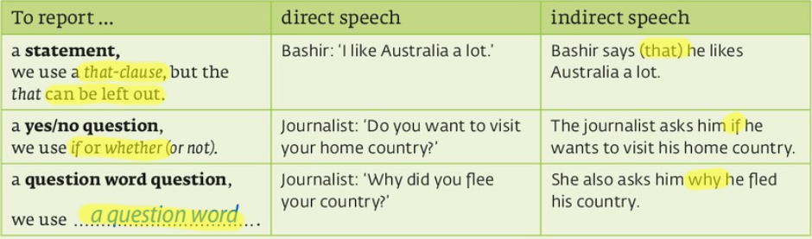
- No backshift
We don’t need to change the tense in indirect speech if what a person said is ………………………...
You don’t change the tense if the reporting verb is in a present tense (e. g. He says).

- Backshift
direct | → | indirect
…………………… | → | past simple
present continuous | → | past continuous
present perfect simple | → | ………………………..
……………… …………. | → | past perfect continuous
past simple | → | past perfect simple
past continuous | → | ……………. …………….
……………….. | → | would
past perfect | ↔ | past perfect (no change)
can | → | could
‘Backshift’ refers to the changes we make to the original verbs in indirect speech (reported clause) because time has passed between the moment of speaking and the time of the report.

- Dropping that
The conjunction that is often dropped, especially after common reporting verbs like: say and …………..

- Says VS said
Jim: I am good at sports.
1) Ana: He says he is good at sports.
2) Ana: He said he was good at sports.
In the first case (He says ...), Ana is reporting quite soon after she has heard Jim say this. Or, she has heard Jim say this quite often (habitually), and she is emphasizing that Jim expresses this opinion of himself often.
In the second case (He said ...), Ana is reporting now what she heard on a previous occasion.
Most of the time when we report speech we use the past (He said).

Change of pronouns, demonstratives and adverbs of place and time
- Pronouns
Changes to personal pronouns in indirect reports depend on whether the person reporting the speech and the person(s) who said the original words are the same or different.
Change of pronouns
Direct speech | Indirect speech
I  You  We  Me  ………  Us | He/she  I/she/she/we/they  …………..  Him/her  Him/her/us/them  Them
My  Your  Our  …………  Yours  Ours | ……….  My/his/hers/our/their  Their  His/hers  Mine/his/hers/ours/theirs  …………..

- Demonstratives & Adverbs of place and time
We often change demonstratives (this, that) and adverbs of time and place (now, here, today, etc.) because indirect speech happens at a later time than the original speech, and perhaps in a different place.
direct | -> | indirect
this | → | that
these | → | …………………..
now | → | Then/ at that moment
…………… | → | the day before
tomorrow | → | the next/following day
two weeks ago | → | two weeks before
here | → | there

Bibliography
Baxter, A. (2014, 04 10). Alice Baxter-BBC World news presenter 5/2/14. Opgehaald van You Tube: https://www.youtube.com/watch?v=fdbrDm1SrqE
CalifJim. (2010, 08 17). reported speech say vs said. Opgehaald van English forums: https://www.englishforums.com/English/ReportedSpeechSayVsSaid/xdkrr/post.htm
English Grammar Today. (sd). Reported speech. Opgehaald van Dictionary Cambridge: https://dictionary.cambridge.org/grammar/british-grammar/reported-speech-indirect-speech
English, B. L. (2018, 03 28). Reported speech: the grammar gameshow episode 25. Opgehaald van You Tube: https://www.youtube.com/watch?v=cetrtFDN2Zg
exercises reported speech. (sd). Opgehaald van My English pages: https://www.myenglishpages.com/site_php_files/grammar-exercise-reported-speech.php
reported speech. (sd). Opgehaald van Englisch-hilfen: https://www.englisch-hilfen.de/en/exercises_list/reported.htm
Reported speech. (sd). Opgehaald van My English pages: https://www.myenglishpages.com/site_php_files/grammar-lesson-reported-speech.php
reported speech exercises. (sd). Opgehaald van agendaweb: https://agendaweb.org/verbs/reported_speech-exercises.html
Seonaid. (sd). reported speech exercises. Opgehaald van Perfect English grammar: https://www.perfect-english-grammar.com/reported-speech-exercises.html
Swan, M. (2018). 258 indirect speech. In M. Swan, Practical English Usage (pp. 257-263). Oxford: Oxford University Press.
Unit 4: A changing world. (2018). In C. D. Johan Delbaere, Ace 3 (pp. 155-157, 178). Kalmthout: Pelckmans.
VVKSO. Leerplan secundair onderwijs Engels tweede graad aso. D/2012/7841/006.

‘Backshift’ refers to the changes we make to the original verbs in indirect speech because time has passed between the moment of speaking and the time of the report.

